Spherical Mirror and Lens W.S. Refer to the following information for the next question:
The radius of curvature of any spherical mirror is R. The distance VC = R is the mirror's radius along its principal axis, while the distance VF = f is the mirror's focal length along the principal axis
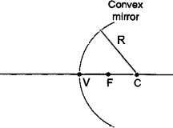

- In the diagram shown above, C is located at the center of the mirror and F is the virtual principal focus. Which equation correctly describes the relationship between the mirror's focal length and its radius?

f = R/2 | f = 2R | f = R/4 | f = 4R
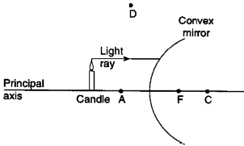
Refer to the following information for the next four questions.

The diagram below shows a light ray parallel to the principal axis of a spherical convex mirror. Point F is the virtual principal focus and C is the mirror's center of curvature.
- After the incident ray strikes the mirror, its reflected ray will pass through which point?

A | C | D | F

- The final image of the candle formed by this mirror will be

upright, virtual, and smaller than the candle
upright, virtual, and the same size as the candle
upright, virtual, and larger than the candle
upright, real, and smaller than the candle
upright, real, and the same size as the candle
upright, real, and larger than the candle

- This type of image is formed because convex mirrors always cause parallel rays of light to

converge | diverge

- If the candle in were to be moved farther away from the front of the mirror, its new image would be in size than it's original image.
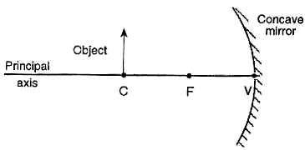
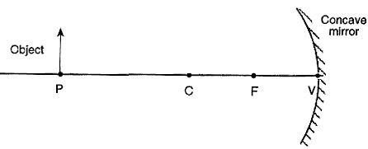
Refer to the following information for the next question.

The object is moved away from the mirror until it reaches position P (PV = 2 CV)
- How does the image formed in the first diagram when the object was located at C compare to the image formed at P?
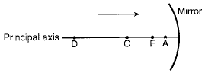
Refer to the following information for the next question.

The diagram below shows a ray of light traveling parallel to the principal axis of a concave spherical mirror. Point F is the principal focus and point C is the center of curvature.

- After the incident ray strikes the mirror, its reflected ray will pass through which point?

A | C | D | F

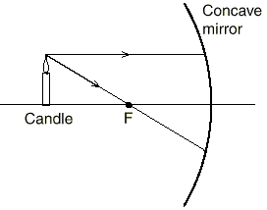
Refer to the following information for the next question.
- After reflecting from the mirror, the two rays of light diagrammed above will to form a image.

converge … real | converge … virtual | diverge … real | diverge … virtual
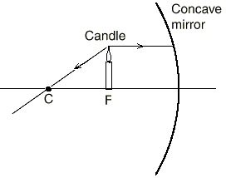
Refer to the following information for the next question.
- After reflecting from the mirror, the two rays of light diagrammed above will .

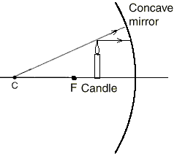
Refer to the following information for the next question.

- After reflecting from the mirror, the two rays of light diagrammed above will to form a image.

converge … real | converge … virtual | diverge … real | diverge … virtual
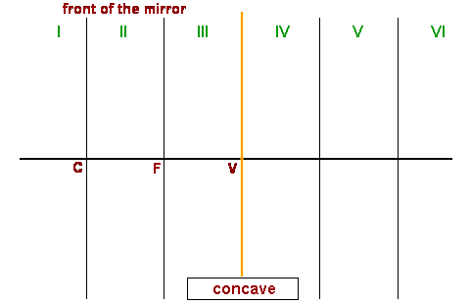
Refer to the following information for the next five questions.
- An object in Region I will always form a in Region .

- An object placed at C will always form a image at .

- An object placed in Region II will always form a image in Region

- An object placed at F will .

- An object placed in Region III will always form a image in Region(s) .
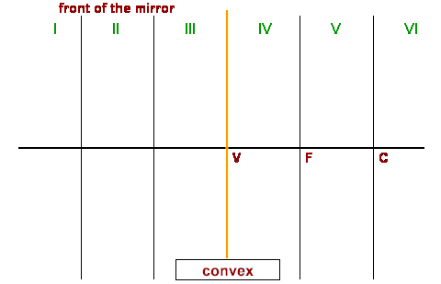
Refer to the following information for the next question.

- An object placed ANYWHERE in front of a convex mirror will always form a image in Region .

Refer to the following information for the next question.

Summary question on plane mirrors:

- An object placed ANYWHERE in front of a plane mirror always produces an image that is

real, inverted, and larger than the object.
real, upright, and the same size as the object.
real, upright, and smaller than the object.
virtual, inverted, and smaller than the object.
virtual, upright, and the same size as the object.

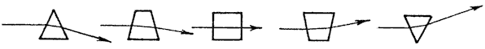
Refer to the following information for the next six questions.

Rays of light bend as shown below when passing through several glass blocks.

18.. Discuss how light rays bend when they pass through the arrangement of glass blocks shown below.
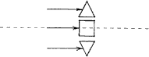

- Sketch how light rays bend when they pass through the lens shown below. Is the lens a converging or a diverging lens? What is your evidence?
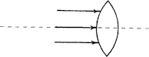

- Discuss how light rays bend when they pass through the arrangement of glass blocks shown below.
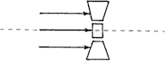

- Sketch how light rays bend when they pass through the lens shown below. Is the lens a converging or a diverging lens? What is your evidence?
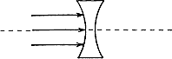

- a. Which type of lens is used to correct farsightedness?

#19, converging | #21, diverging

b. Which type of lens is used to correct nearsightedness?

#19, converging | #21, diverging

!

Refer to the following information for the next five questions:
Construct rays to find the location and relative size of the arrow's image for each of the lenses below. Rays that pass through the middle of a lens continue undeviated. In a converging lens, rays from the tip of the arrow that are parallel to the optic axis extend through the far focal point after going through the lens. Rays that go through the near focal point go parallel to the axis after going through the lens. In a diverging lens, rays parallel to the axis diverge and appear to originate from the near focal point after passing though the lens. Have fun!
In each case, describe what type of image is formed (real or virtual), whether it is upright or inverted, enlarged or reduced, and where it is located.
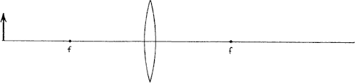

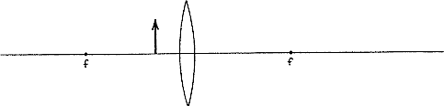

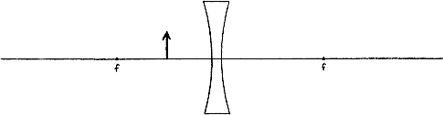

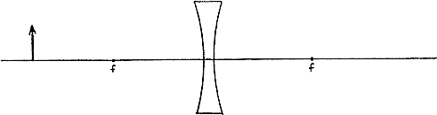
- A lens (shape) is thicker in the center than on the edges.

- When used individually, a lens usually forms real images.

- When formed by a single lens, a _ image is always inverted.

- When formed by a single lens, a image is always upright.

31.. Virtual images formed by converging lenses are compared to the object.

enlarged in size | the same size | reduced in size

- A _ image can be projected onto a screen.

- A image is said to be "trapped" in the lens.

- When light passes through a lens, its frequency __.

decreases | remains the same | increases

- A ray that starts from the top of an object and runs parallel to the axis of the lens, would then pass through the .

principal focus of the lens | center of the lens | secondary focus of the lens

- A ray that starts from the top of an object and passes through the would leave the lens running parallel to its axis.

principal focus of the lens | center of the lens | secondary focus of the lens

- A ray that starts from the top of an object and passes through the would leave the lens totally straight.

principal focus of the lens | center of the lens | secondary focus of the lens

- . When used in air, which set of terms are synonymous?

convex, diverging | convex, converging

39.. For a converging lens, its is located on the same side of the lens as the object.

principal focus | center | secondary focus

- After passing through a lens, rays of light traveling parallel to a lens' axis are refracted to the lens'
.

principal focus | center | secondary focus

- Real images are formed by rays of light that have passed through a lens.

converging | parallel | diverging

- Virtual images are formed by rays of light that have passed through a lens.

converging | parallel | diverging

- Images which are closer to the lens than the object are than the size of the object.

reduced in size | equal in size | greater in size

- images are located on the same side of the lens as the object - that is, by looking in one direction, the observer can see both the image and the object.

Real | Virtual

- images are located on the opposite side of the lens as the object - that is, when an observer is look in one direction to see the image, the object is "behind his back" in the opposite direction. He cannot view both the image and the object in the same direction.

Real | Virtual

- When an object is located greater than two focal lengths in front of a converging lens, the image it produces will be .

real & enlarged | virtual & enlarged | real & reduced | virtual & reduced
- A _ lens (shape) is thinner in the center than on the edges.

48.. When used individually, a lens always forms virtual images.

- When formed by a single lens, a image is always inverted.

- When formed by a single lens, a image is always upright.

- Virtual images formed by diverging lenses are compared to the object.

enlarged in size | the same size | reduced in size

- While virtual images formed by converging lenses are compared to the object.

enlarged in size | the same size | reduced in size

- A image is said to be "trapped" in the lens.

- When used in air, which set of terms are synonymous?

convex, diverging | concave, diverging

- After passing through a diverging lens, rays of light traveling parallel to a lens' axis are refraction to the lens' .

principal focus of the lens | center of the lens | secondary focus of the lens

- A ray that starts from the top of an object aiming for the would leave a diverging lens running parallel to its axis.

principal focus of the lens | center of the lens | secondary focus of the lens

- A ray that starts from the top of an object and passes through the would leave a diverging lens totally straight.

principal focus of the lens | center of the lens | secondary focus of the lens

- For a diverging lens, its is located on the same side of the lens as the object.

principal focus | center | secondary focus

- Virtual images are formed by rays of light that have passed through a lens.

converging | parallel | diverging

- images are located on the same side of the lens as the object - that is, by looking in one direction, the observer can see both the image and the object.

Real | Virtual
- REVIEW: A small object is placed in a room with a narrow mirror on the wall. Four positions in the room are labeled W, X, Y, and Z, as shown below.
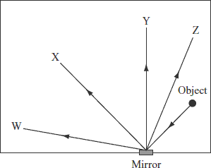

At which position should a person stand to see the reflection of the object in the mirror?

A. position W | B. position X | C. position Y | D. position Z
- REVIEW: The picture below shows what a straight pipe looks like in a container of water when viewed from the side.
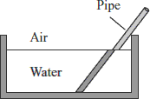

What is happening in this example as light travels from the water into the air?

A. absorption | B. diffraction | C. reflection | D. refraction
- REVIEW: A light ray striking the flat surface of a piece of clear hard plastic at an angle of 45°. Light travels faster in air than through plastic.
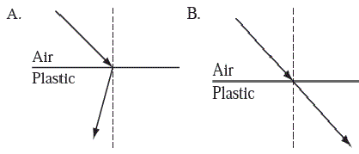
Which of the following diagrams shows how the ray is refracted after it travels through the plastic?

